**Docker**

**1: Install Docker Desktop**

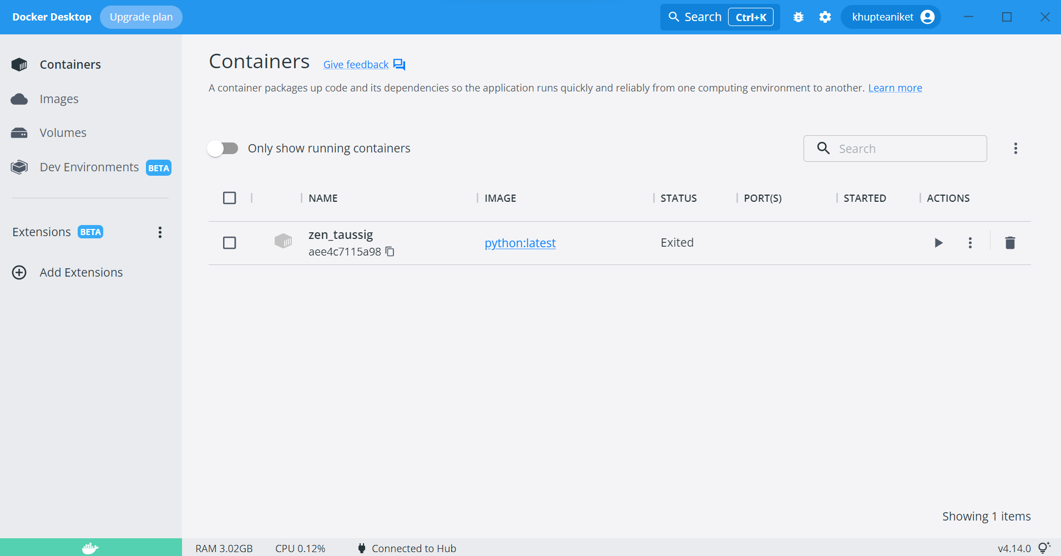

**2: Create Dockerfile**

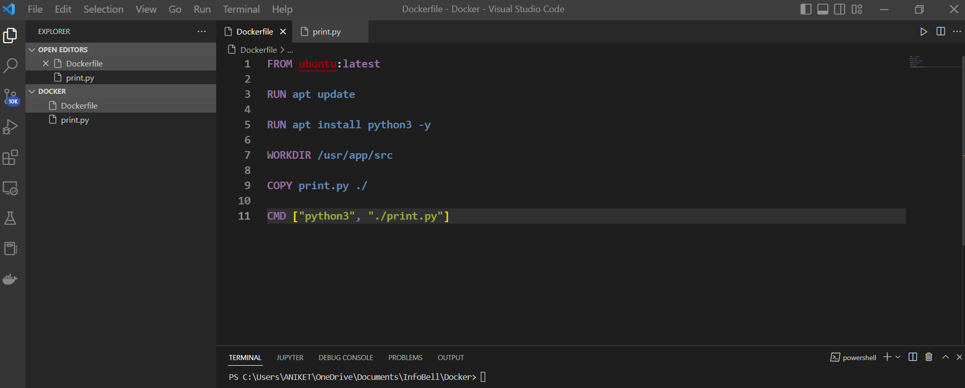

**3: Create an Image**

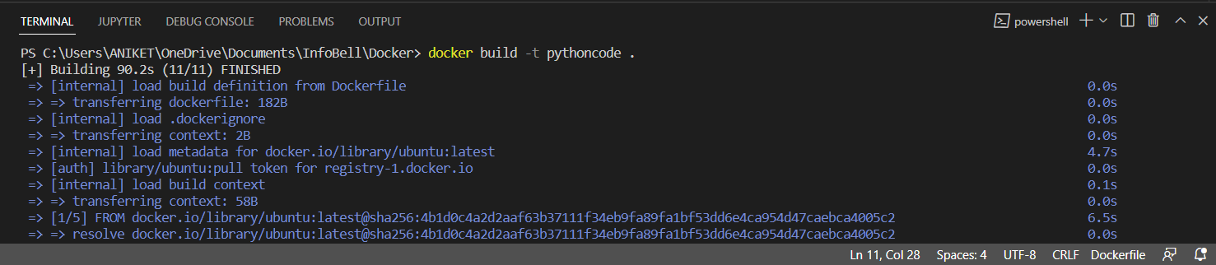

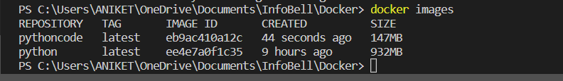

**4: Image by Docker Desktop**

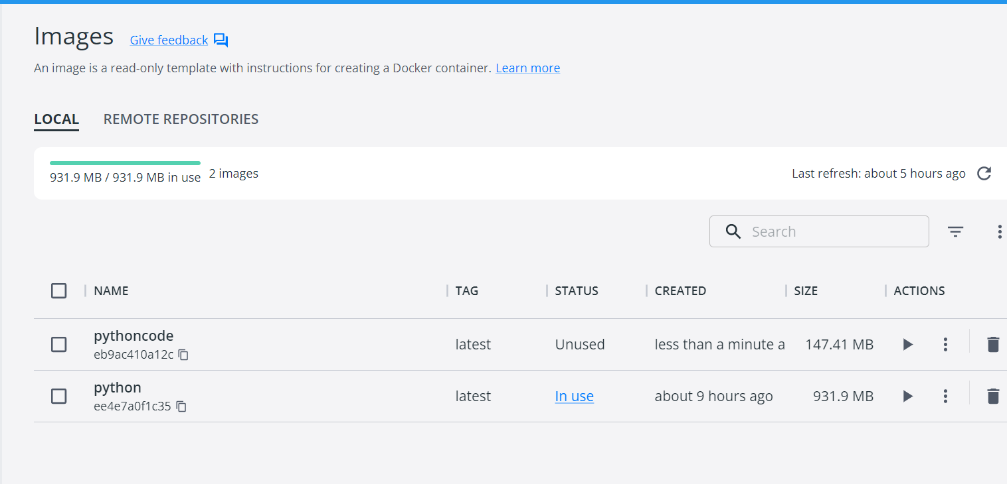

**5: Containers**

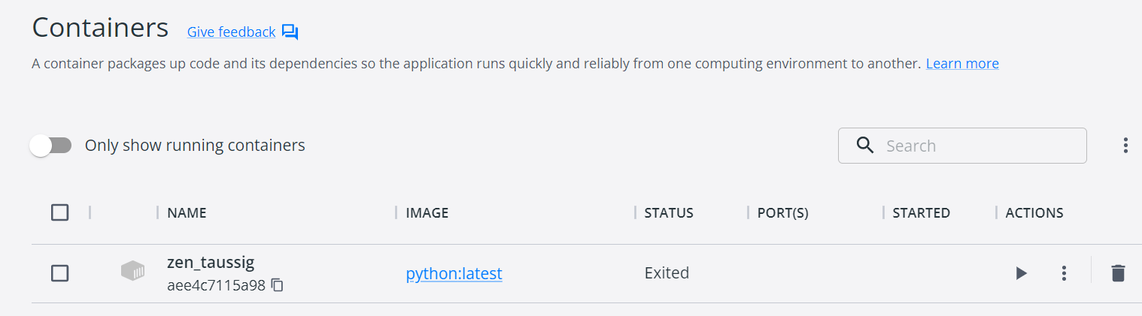

**6: Running Python Scripts**

